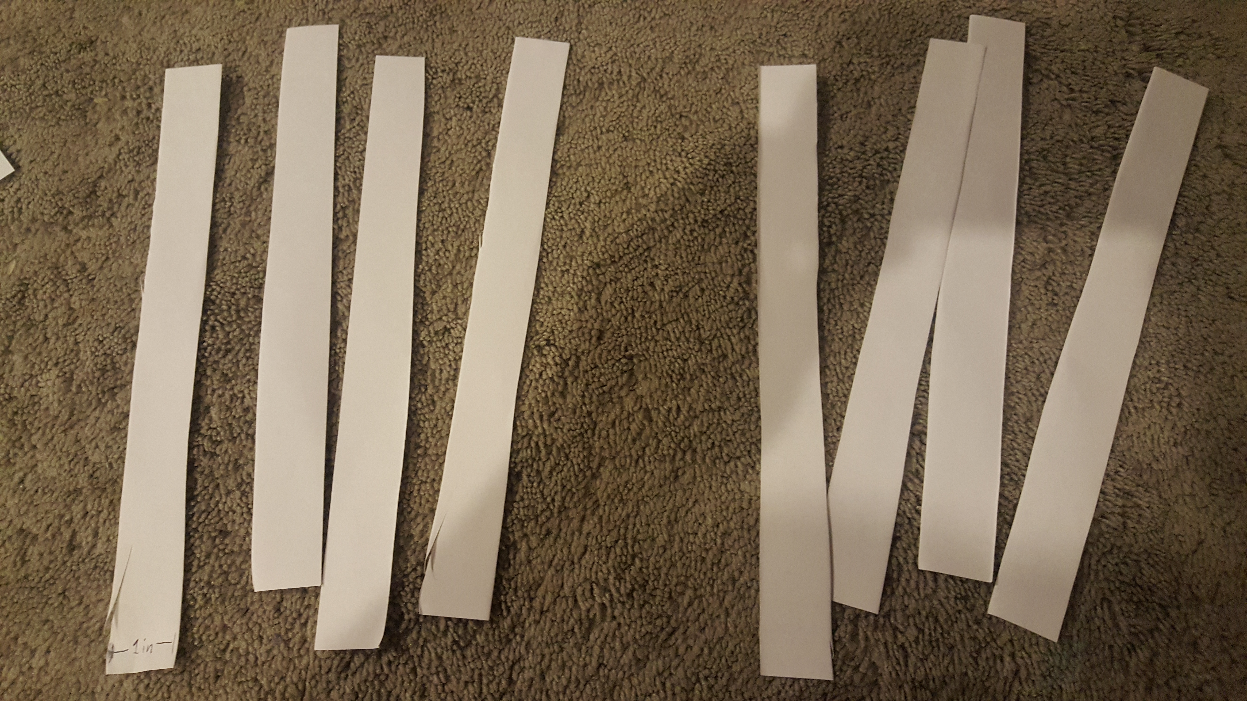

1.) Cut paper into x8 1-inch sheets width-wise.

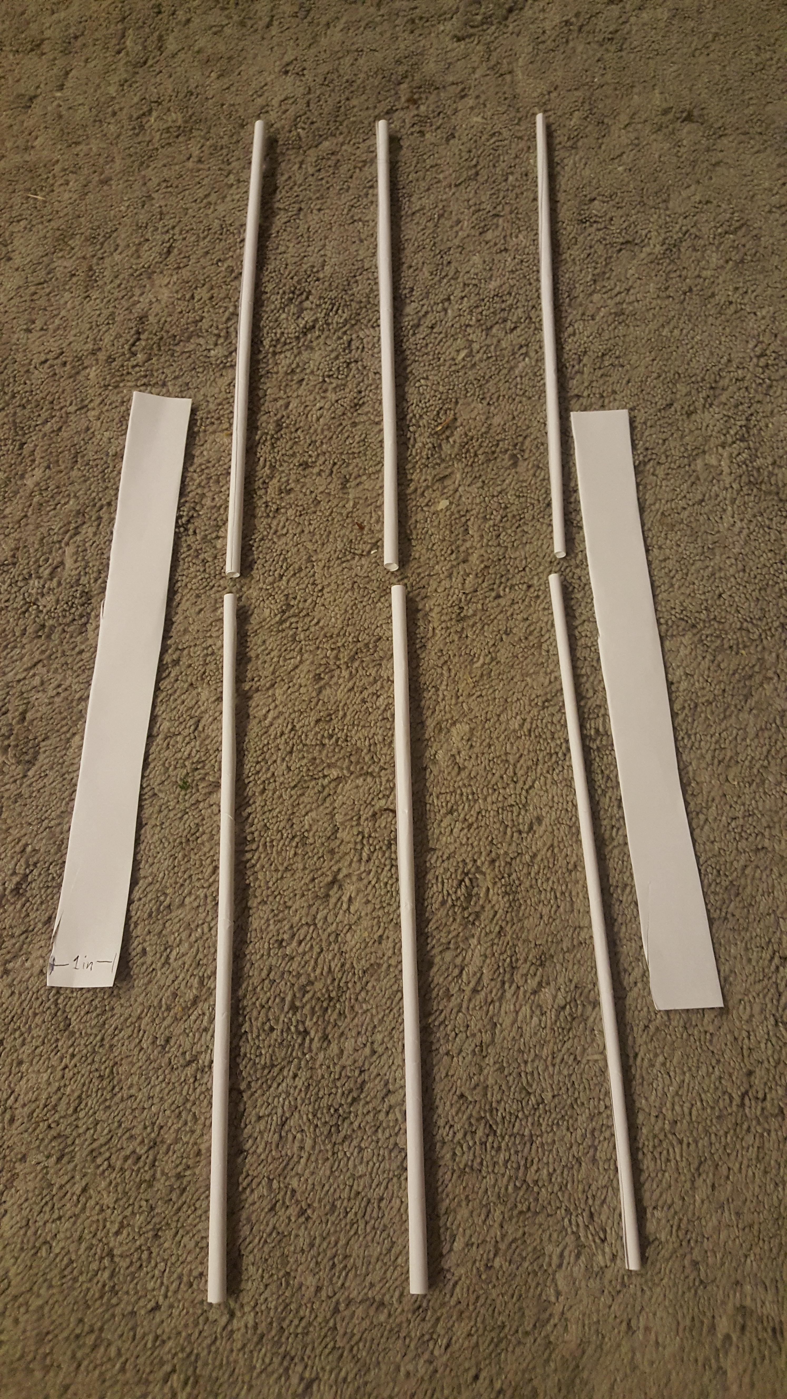

2.) Roll up 6 of the strips into tight tubes length-wise.

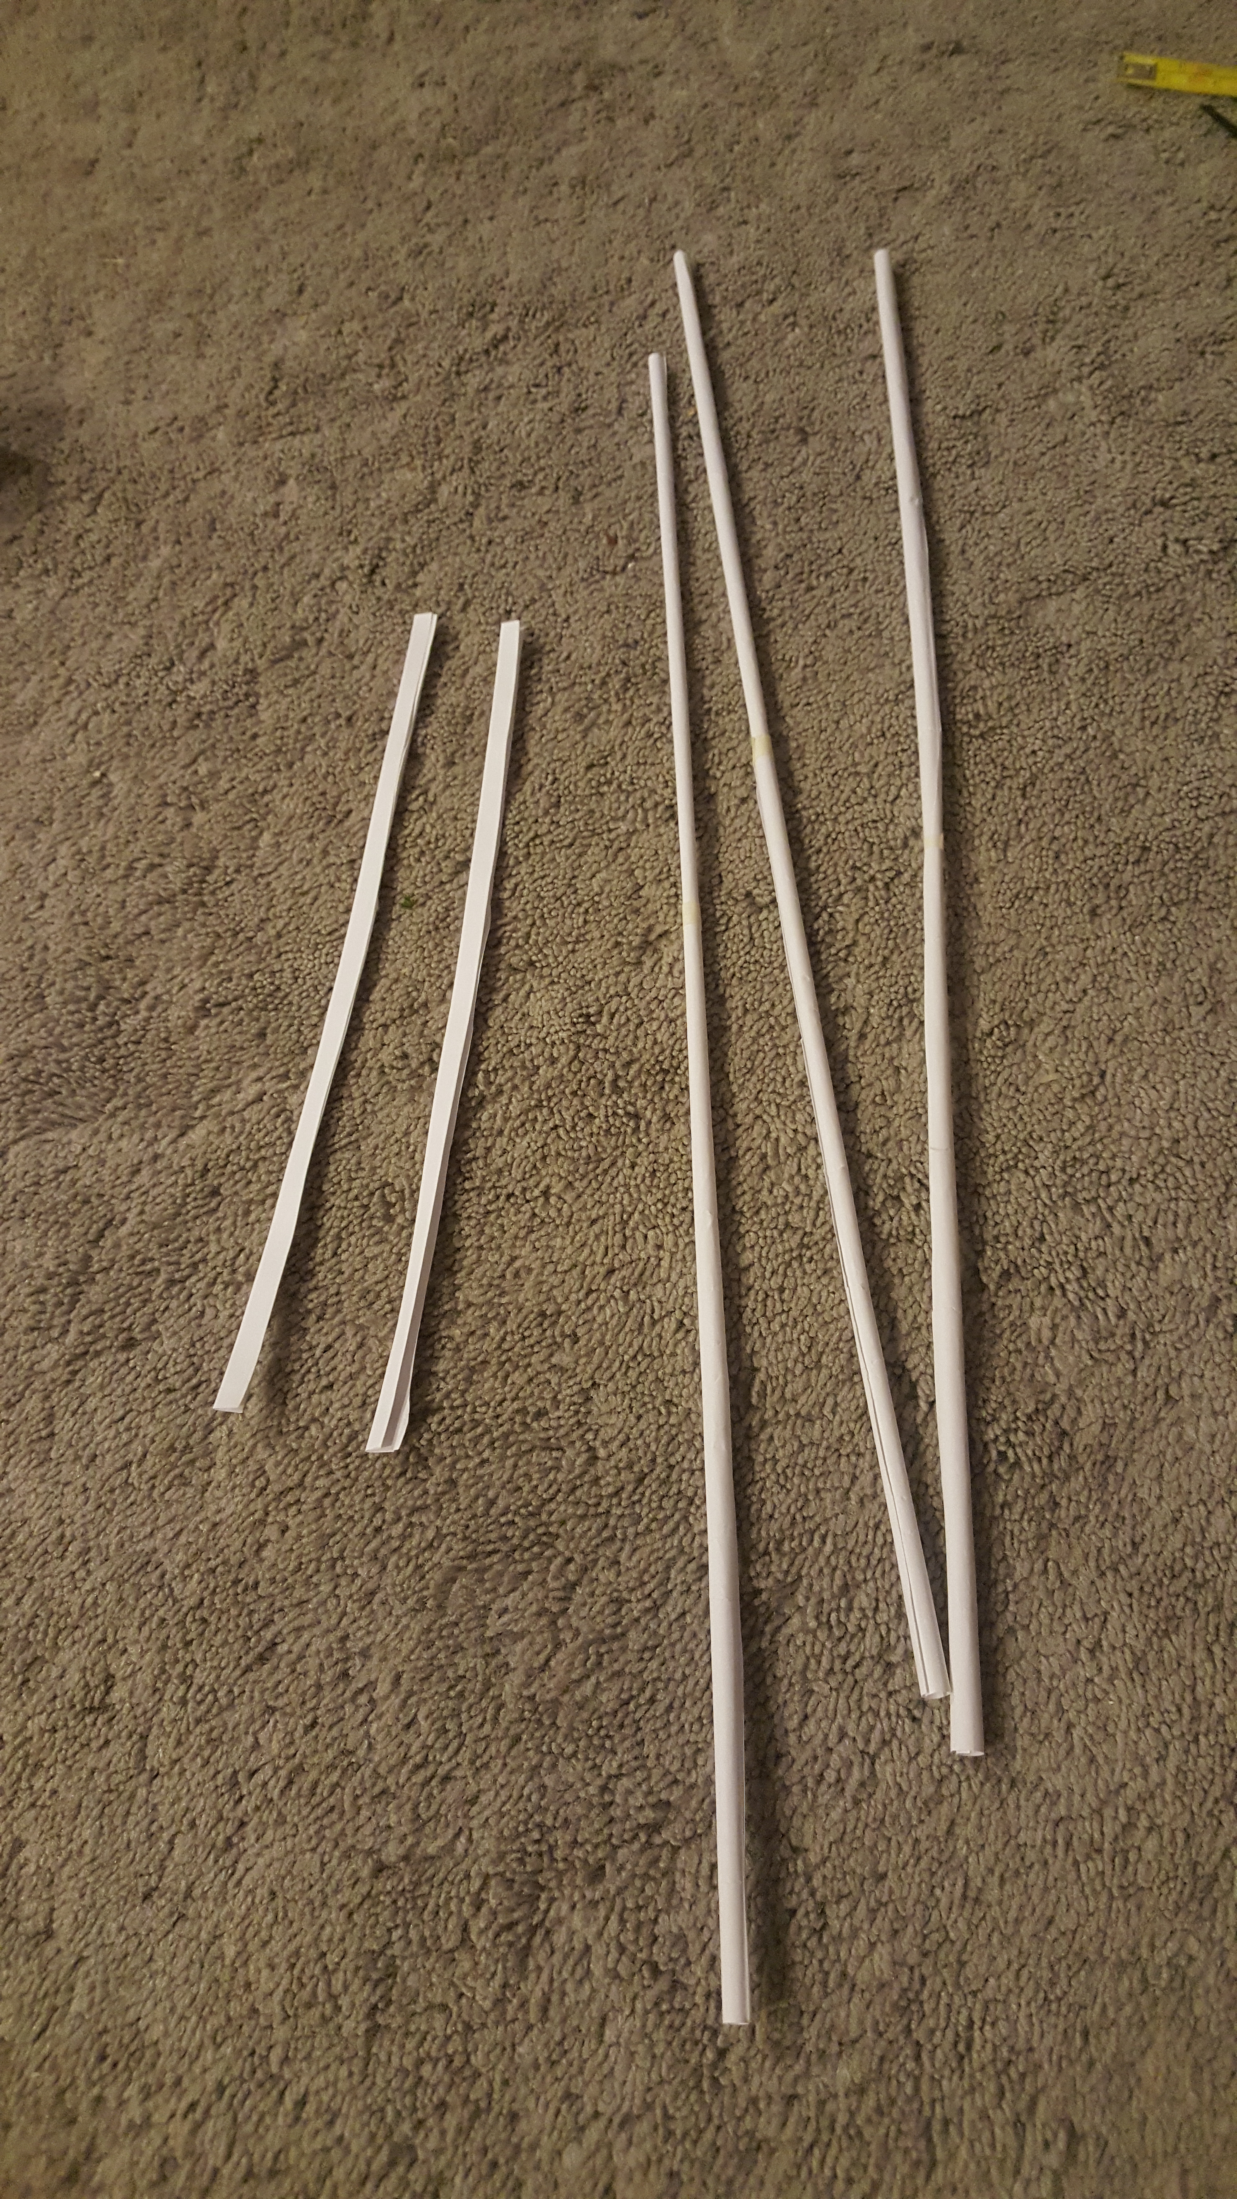

3.) Fold your last 2 strips 4 times width-wise.

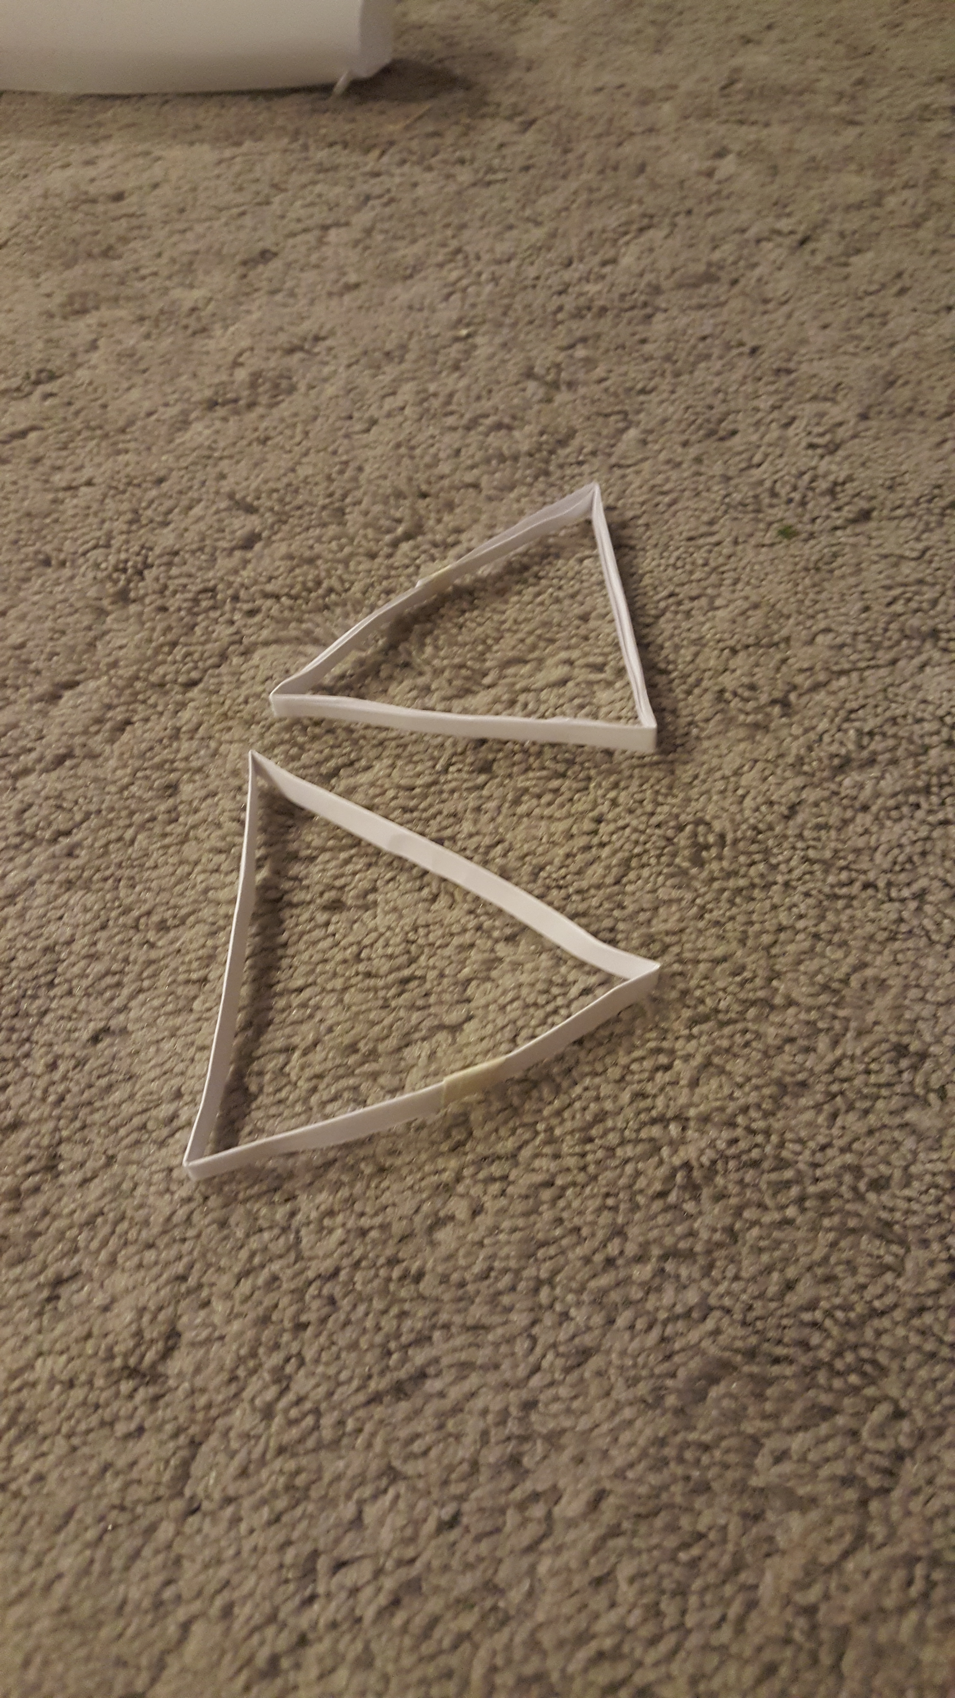

4.) Tape the 2 strips you just folded into a circle.

5.) Then pinch some corners to make an equilateral triangle.

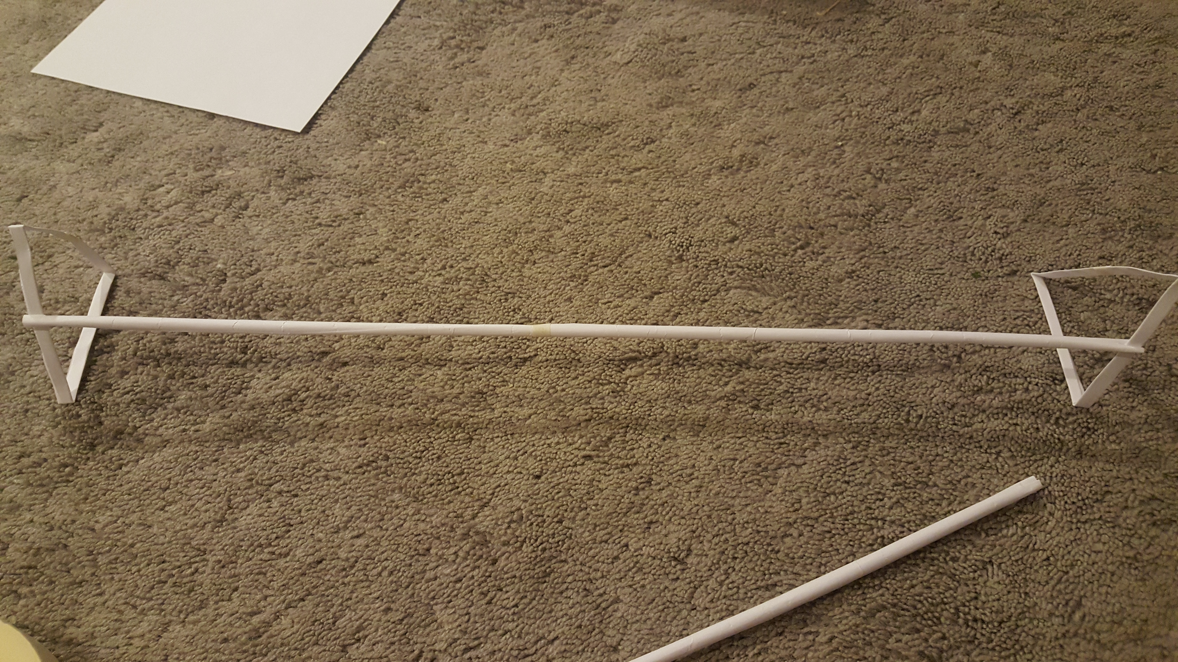

5.) Pair each tube and tape them together.

6.) Cut notches into both ends of all your tubes.

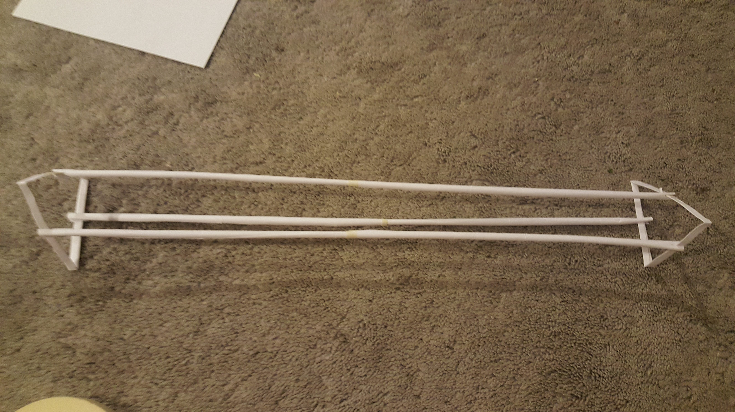

6.) Start sliding the triangle into the notches as shown.

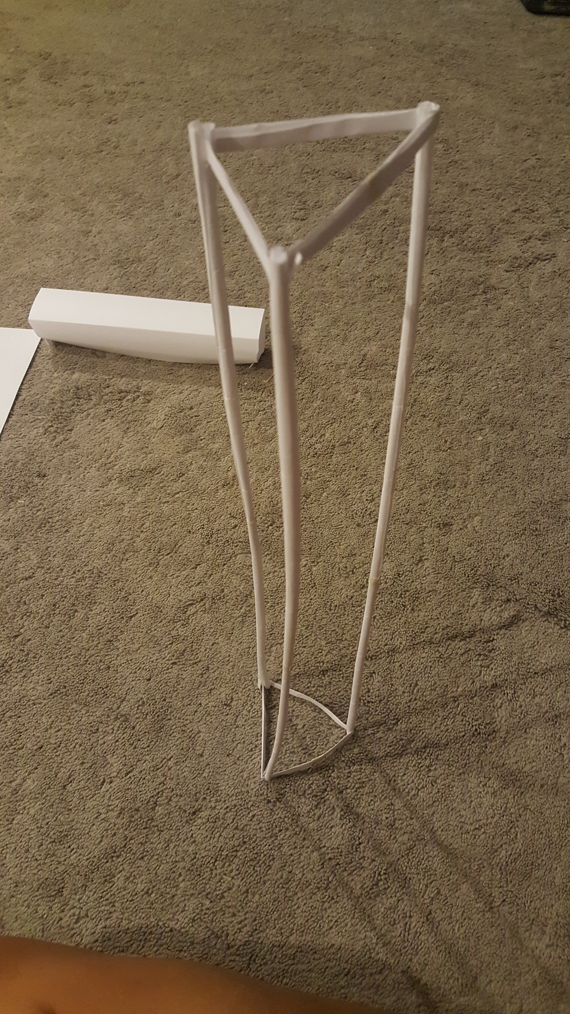

7.) Push all the tubes into the corners of the triangle and stand your tower up.

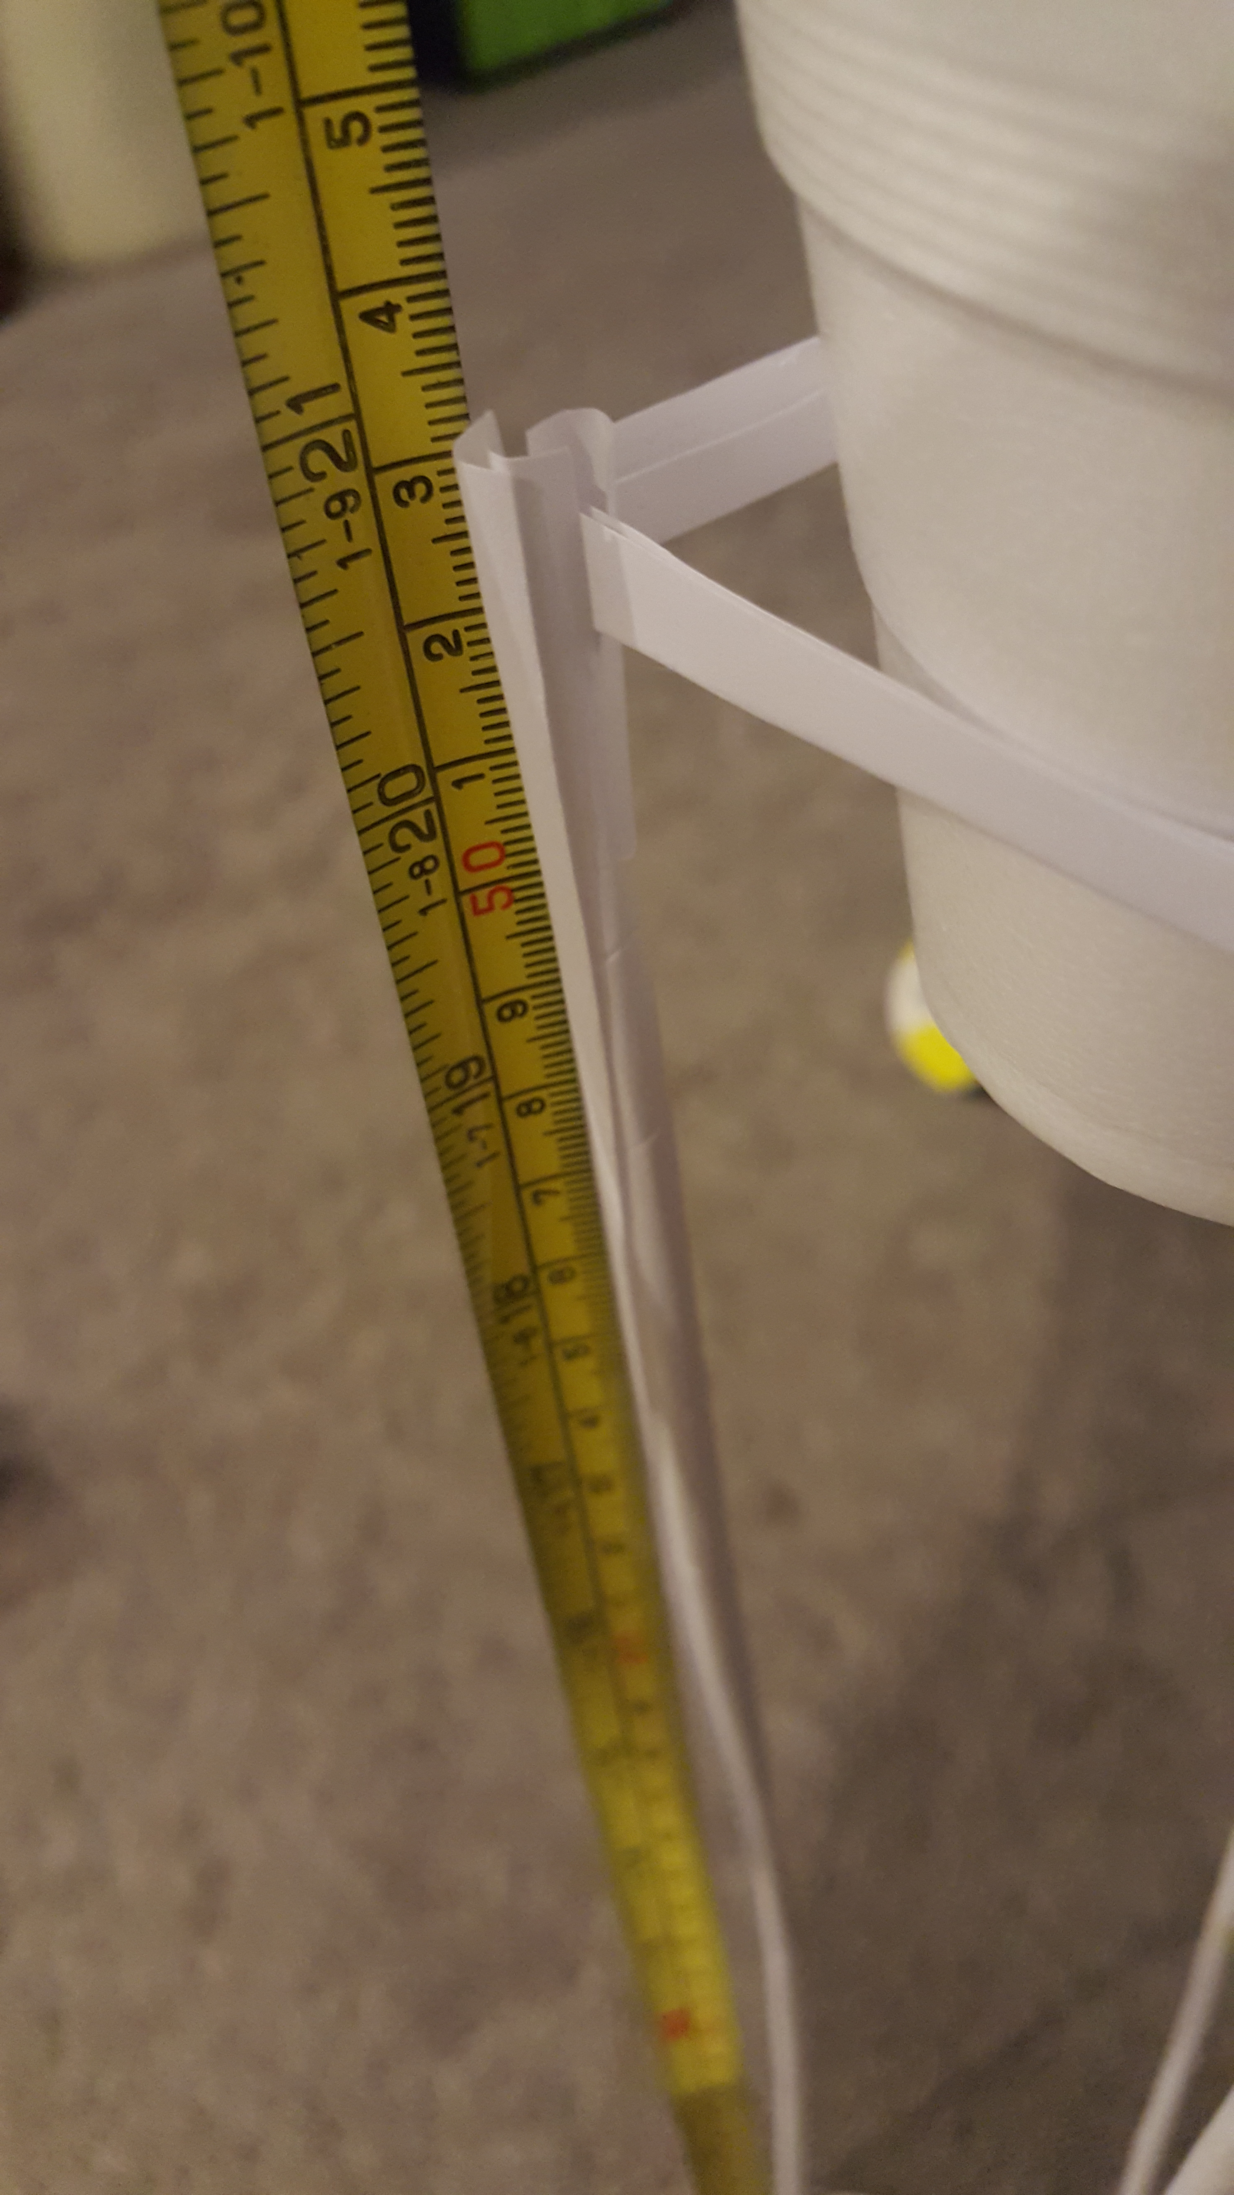

Final height 21 inches.